# **CSS Backgrounds**

The CSS background properties are used to add background effects for elements.

In these chapters, you will learn about the following CSS background properties:

* background-color
* background-image
* background-repeat
* background-attachment
* background-position
* background (shorthand property)

## CSS background-color

The background-color property specifies the background color of an element.

With CSS, a color is most often specified by:

* a valid color name - like "red"
* a HEX value - like "#ff0000"
* an RGB value - like "rgb(255,0,0)"

## Opacity / Transparency

The opacity property specifies the opacity/transparency of an element. It can take a value from 0.0 - 1.0. The lower value, the more transparent

**Note:** When using the opacity property to add transparency to the background of an element, all of its child elements inherit the same transparency. This can make the text inside a fully transparent element hard to read.

## CSS background-image

The background-image property specifies an image to use as the background of an element.

By default, the image is repeated so it covers the entire element.

**Note:** When using a background image, use an image that does not disturb the text.

## CSS background-repeat

By default, the background-image property repeats an image both horizontally and vertically.

**Tip:** To repeat an image vertically, set background-repeat: repeat-y;

## CSS background-repeat: no-repeat

Showing the background image only once is also specified by the background-repeat property

## CSS background-position

The background-position property is used to specify the position of the background image.

## CSS background-attachment

The background-attachment property specifies whether the background image should scroll or be fixed (will not scroll with the rest of the page)

## CSS background - Shorthand property

To shorten the code, it is also possible to specify all the background properties in one single property. This is called a shorthand property.

body {  
  background-color: #ffffff;  
  background-image: url("img_tree.png");  
  background-repeat: no-repeat;  
  background-position: right top;  
}

body {  
  background: #ffffff url("img_tree.png") no-repeat right top;  
}

When using the shorthand property the order of the property values is:

* background-color
* background-image
* background-repeat
* background-attachment
* background-position

It does not matter if one of the property values is missing, as long as the other ones are in this order. Note that we do not use the background-attachment property in the examples above, as it does not have a value.

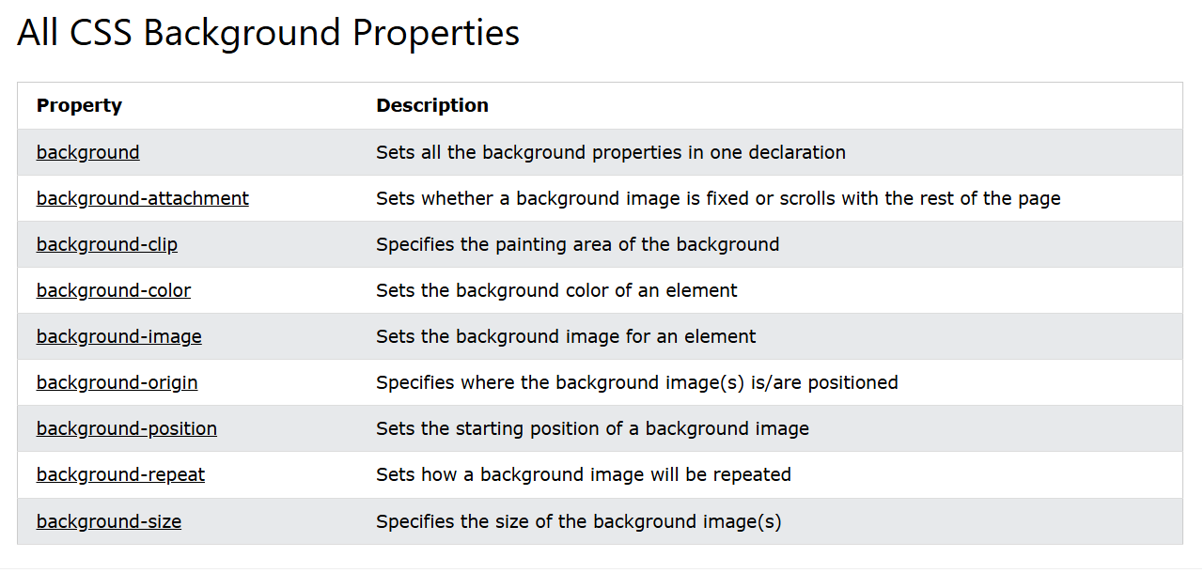

# **CSS Borders**

The CSS border properties allow you to specify the style, width, and color of an element's border.

CSS Border Style

The border-style property specifies what kind of border to display.

The following values are allowed:

* dotted - Defines a dotted border
* dashed - Defines a dashed border
* solid - Defines a solid border
* double - Defines a double border
* groove - Defines a 3D grooved border. The effect depends on the border-color value
* ridge - Defines a 3D ridged border. The effect depends on the border-color value
* inset - Defines a 3D inset border. The effect depends on the border-color value
* outset - Defines a 3D outset border. The effect depends on the border-color value
* none - Defines no border
* hidden - Defines a hidden border

The border-style property can have from one to four values (for the top border, right border, bottom border, and the left border).

## CSS Border Width

The border-width property specifies the width of the four borders.

The width can be set as a specific size (in px, pt, cm, em, etc) or by using one of the three pre-defined values: thin, medium, or thick

## Specific Side Widths

The border-width property can have from one to four values (for the top border, right border, bottom border, and the left border)

CSS Border Color

The border-color property is used to set the color of the four borders.

The color can be set by:

* name - specify a color name, like "red"
* HEX - specify a HEX value, like "#ff0000"
* RGB - specify a RGB value, like "rgb(255,0,0)"
* HSL - specify a HSL value, like "hsl(0, 100%, 50%)"
* transparent

**Note:** If border-color is not set, it inherits the color of the element.

## Specific Side Colors

The border-color property can have from one to four values (for the top border, right border, bottom border, and the left border).

border-style: solid;

border-color: red green blue yellow;

## RGB Values

## border-color: rgb(255, 0, 0);

## HSL Values

border-color: hsl(0, 100%, 50%);

## CSS Border - Individual Sides

From the examples on the previous pages, you have seen that it is possible to specify a different border for each side.

In CSS, there are also properties for specifying each of the borders (top, right, bottom, and left)

border-top-style: dotted;  
  border-right-style: solid;  
  border-bottom-style: dotted;  
  border-left-style: solid;

If the border-style property has four values:

* **border-style: dotted solid double dashed;**
  + top border is dotted
  + right border is solid
  + bottom border is double
  + left border is dashed

If the border-style property has three values:

* **border-style: dotted solid double;**
  + top border is dotted
  + right and left borders are solid
  + bottom border is double

If the border-style property has two values:

* **border-style: dotted solid;**
  + top and bottom borders are dotted
  + right and left borders are solid

If the border-style property has one value:

* **border-style: dotted;**
  + all four borders are dotted

CSS Border - Shorthand Property

Like you saw in the previous page, there are many properties to consider when dealing with borders.

To shorten the code, it is also possible to specify all the individual border properties in one property.

The border property is a shorthand property for the following individual border properties:

* border-width
* border-style (required)
* border-color

border: 5px solid red;

## CSS Rounded Borders

The border-radius property is used to add rounded borders to an element

border: 2px solid red;  
  border-radius: 5px;

## All CSS Border Properties

|  |  |
| --- | --- |
| **Property** | **Description** |
| [border](https://www.w3schools.com/cssref/pr_border.php) | Sets all the border properties in one declaration |
| [border-bottom](https://www.w3schools.com/cssref/pr_border-bottom.php) | Sets all the bottom border properties in one declaration |
| [border-bottom-color](https://www.w3schools.com/cssref/pr_border-bottom_color.php) | Sets the color of the bottom border |
| [border-bottom-style](https://www.w3schools.com/cssref/pr_border-bottom_style.php) | Sets the style of the bottom border |
| [border-bottom-width](https://www.w3schools.com/cssref/pr_border-bottom_width.php) | Sets the width of the bottom border |
| [border-color](https://www.w3schools.com/cssref/pr_border-color.php) | Sets the color of the four borders |
| [border-left](https://www.w3schools.com/cssref/pr_border-left.php) | Sets all the left border properties in one declaration |
| [border-left-color](https://www.w3schools.com/cssref/pr_border-left_color.php) | Sets the color of the left border |
| [border-left-style](https://www.w3schools.com/cssref/pr_border-left_style.php) | Sets the style of the left border |
| [border-left-width](https://www.w3schools.com/cssref/pr_border-left_width.php) | Sets the width of the left border |
| [border-radius](https://www.w3schools.com/cssref/css3_pr_border-radius.php) | Sets all the four border-*-radius properties for rounded corners |
| [border-right](https://www.w3schools.com/cssref/pr_border-right.php) | Sets all the right border properties in one declaration |
| [border-right-color](https://www.w3schools.com/cssref/pr_border-right_color.php) | Sets the color of the right border |
| [border-right-style](https://www.w3schools.com/cssref/pr_border-right_style.php) | Sets the style of the right border |
| [border-right-width](https://www.w3schools.com/cssref/pr_border-right_width.php) | Sets the width of the right border |
| [border-style](https://www.w3schools.com/cssref/pr_border-style.php) | Sets the style of the four borders |
| [border-top](https://www.w3schools.com/cssref/pr_border-top.php) | Sets all the top border properties in one declaration |
| [border-top-color](https://www.w3schools.com/cssref/pr_border-top_color.php) | Sets the color of the top border |
| [border-top-style](https://www.w3schools.com/cssref/pr_border-top_style.php) | Sets the style of the top border |
| [border-top-width](https://www.w3schools.com/cssref/pr_border-top_width.php) | Sets the width of the top border |
| [border-width](https://www.w3schools.com/cssref/pr_border-width.php) | Sets the width of the four borders |

# **CSS Margins**

Margins are used to create space around elements, outside of any defined borders.

CSS Margins

The CSS margin properties are used to create space around elements, outside of any defined borders.

With CSS, you have full control over the margins. There are properties for setting the margin for each side of an element (top, right, bottom, and left).

Margin - Individual Sides

CSS has properties for specifying the margin for each side of an element:

* margin-top
* margin-right
* margin-bottom
* margin-left

All the margin properties can have the following values:

* auto - the browser calculates the margin
* *length* - specifies a margin in px, pt, cm, etc.
* *%* - specifies a margin in % of the width of the containing element
* inherit - specifies that the margin should be inherited from the parent element

**Tip:** Negative values are allowed.

Margin - Shorthand Property

To shorten the code, it is possible to specify all the margin properties in one property.

The margin property is a shorthand property for the following individual margin properties:

* margin-top
* margin-right
* margin-bottom
* margin-left

So, here is how it works:

If the margin property has four values:

* **margin: 25px 50px 75px 100px;**
  + top margin is 25px
  + right margin is 50px
  + bottom margin is 75px
  + left margin is 100px

If the margin property has three values:

* **margin: 25px 50px 75px;**
  + top margin is 25px
  + right and left margins are 50px
  + bottom margin is 75px

If the margin property has two values:

* **margin: 25px 50px;**
  + top and bottom margins are 25px
  + right and left margins are 50px

If the margin property has one value:

* **margin: 25px;**
  + all four margins are 25px

## The auto Value

You can set the margin property to auto to horizontally center the element within its container.

The element will then take up the specified width, and the remaining space will be split equally between the left and right margins.

## The inherit Value

This example lets the left margin of the <p class="ex1"> element be inherited from the parent element (<div>)

border: 1px solid red;  
margin-left: 100px;

margin-left: inherit;

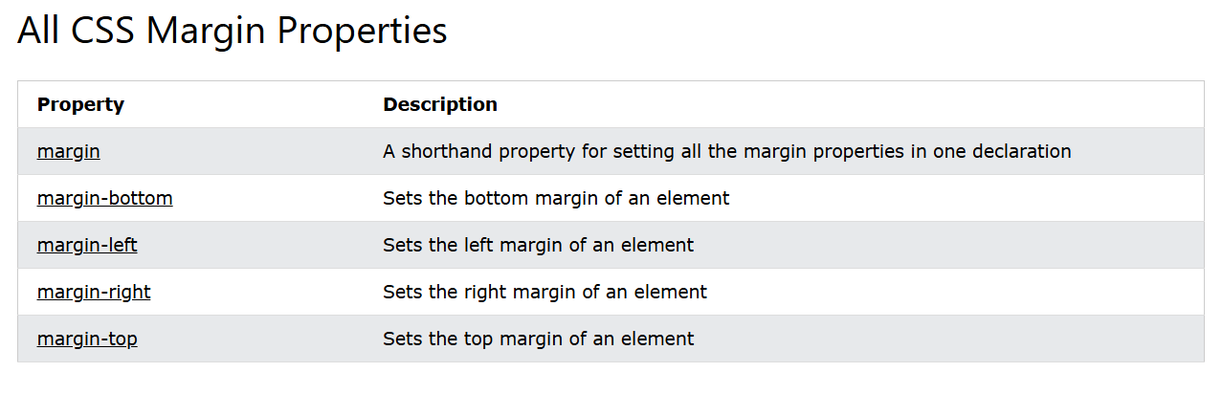

# **CSS Margin Collapse**

Sometimes two margins collapse into a single margin.

## Margin Collapse

Top and bottom margins of elements are sometimes collapsed into a single margin that is equal to the largest of the two margins.

This does not happen on left and right margins! Only top and bottom margins!

Demonstration of margin collapse:

h1 {  
  margin: 0 0 50px 0;  
}  
  
h2 {  
  margin: 20px 0 0 0;  
}

In the example above, the <h1> element has a bottom margin of 50px and the <h2> element has a top margin set to 20px.

Common sense would seem to suggest that the vertical margin between the <h1> and the <h2> would be a total of 70px (50px + 20px). But due to margin collapse, the actual margin ends up being 50px.

# **CSS Padding**

Padding is used to create space around an element's content, inside of any defined borders.

The CSS padding properties are used to generate space around an element's content, inside of any defined borders.

With CSS, you have full control over the padding. There are properties for setting the padding for each side of an element (top, right, bottom, and left).

Padding - Individual Sides

CSS has properties for specifying the padding for each side of an element:

* padding-top
* padding-right
* padding-bottom
* padding-left

All the padding properties can have the following values:

* *length* - specifies a padding in px, pt, cm, etc.
* *%* - specifies a padding in % of the width of the containing element
* inherit - specifies that the padding should be inherited from the parent element

**Note:** Negative values are not allowed.

Padding - Shorthand Property

To shorten the code, it is possible to specify all the padding properties in one property.

The padding property is a shorthand property for the following individual padding properties:

* padding-top
* padding-right
* padding-bottom
* padding-left

So, here is how it works:

If the padding property has four values:

* **padding: 25px 50px 75px 100px;**
  + top padding is 25px
  + right padding is 50px
  + bottom padding is 75px
  + left padding is 100px

If the padding property has three values:

* **padding: 25px 50px 75px;**
  + top padding is 25px
  + right and left paddings are 50px
  + bottom padding is 75px

If the padding property has two values:

* **padding: 25px 50px;**
  + top and bottom paddings are 25px
  + right and left paddings are 50px

If the padding property has one value:

* **padding: 25px;**
  + all four paddings are 25px

## Padding and Element Width

The CSS width property specifies the width of the element's content area. The content area is the portion inside the padding, border, and margin of an element ([the box model](https://www.w3schools.com/css/css_boxmodel.asp)).

So, if an element has a specified width, the padding added to that element will be added to the total width of the element. This is often an undesirable result.

# **CSS Height, Width and Max-width**

The CSS height and width properties are used to set the height and width of an element.

The CSS max-width property is used to set the maximum width of an element.

CSS Setting height and width

The height and width properties are used to set the height and width of an element.

The height and width properties do not include padding, borders, or margins. It sets the height/width of the area inside the padding, border, and margin of the element.

CSS height and width Values

The height and width properties may have the following values:

* auto - This is default. The browser calculates the height and width
* length - Defines the height/width in px, cm, etc.
* % - Defines the height/width in percent of the containing block
* initial - Sets the height/width to its default value
* inherit - The height/width will be inherited from its parent value

**Note:** Remember that the height and width properties do not include padding, borders, or margins! They set the height/width of the area inside the padding, border, and margin of the element!

## Setting max-width

The max-width property is used to set the maximum width of an element.

The max-width can be specified in length values, like px, cm, etc., or in percent (%) of the containing block, or set to none (this is default. Means that there is no maximum width).

The problem with the <div> above occurs when the browser window is smaller than the width of the element (500px). The browser then adds a horizontal scrollbar to the page.

In this situation, using max-width will improve the browser's handling of small windows.

**Tip:** Drag the browser window to smaller than 500px wide, to see the difference between the two divs!

**Note:** If you for some reason use both the width property and the max-width property on the same element, and the value of the width property is larger than the max-width property; the max-width property will be used (and the width property will be ignored).

## The CSS Box Model

In CSS, the term "box model" is used when talking about design and layout.

The CSS box model is essentially a box that wraps around every HTML element. It consists of: content, padding, borders and margins. The image below illustrates the box model

Explanation of the different parts:

* **Content** - The content of the box, where text and images appear
* **Padding** - Clears an area around the content. The padding is transparent
* **Border** - A border that goes around the padding and content
* **Margin** - Clears an area outside the border. The margin is transparent

The box model allows us to add a border around elements, and to define space between elements.

## Width and Height of an Element

In order to set the width and height of an element correctly in all browsers, you need to know how the box model works.

**Important:** When you set the width and height properties of an element with CSS, you just set the width and height of the **content area**. To calculate the total width and height of an element, you must also include the padding and borders.

320px (width of content area)  
+ 20px (left padding + right padding)  
+ 10px (left border + right border)  
**= 350px (total width)**  
  
  50px (height of content area)  
+ 20px (top padding + bottom padding)  
+ 10px (top border + bottom border)  
**= 80px (total height)**

The total width of an element should be calculated like this:

Total element width = width + left padding + right padding + left border + right border

The total height of an element should be calculated like this:

Total element height = height + top padding + bottom padding + top border + bottom border

**Note:** The margin property also affects the total space that the box will take up on the page, but the margin is not included in the actual size of the box. The box's total width and height stops at the border.